VISHWAKARMA UNIVERSITY
Academic Year: 2025-26 | Semester II
ADVANCED WEB TECHNOLOGY
NAME OF THE STUDENT : | Aaditya Dhanwate
DEPARTMENT : | ARTIFICIAL INTELLIGENCE & DATA SCIENCE
CLASS / DIV. : | TY / A
SRN : | 31230319
ROLL NO. : | 8

ASSIGNMENT NO.: 03
React Application for Student Management System with Routing
OBJECTIVE:
• Build a React application with multiple pages: Home, Register, Login, Contact, and About
• Implement client-side routing using React Router DOM
• Design a responsive navbar with active link highlighting for seamless navigation

Problem Statement: Create a React application for a Student Management System having Registration, Login, Contact, and About pages. Implement routing using React Router DOM to navigate through these pages with a persistent navigation bar.
Output:
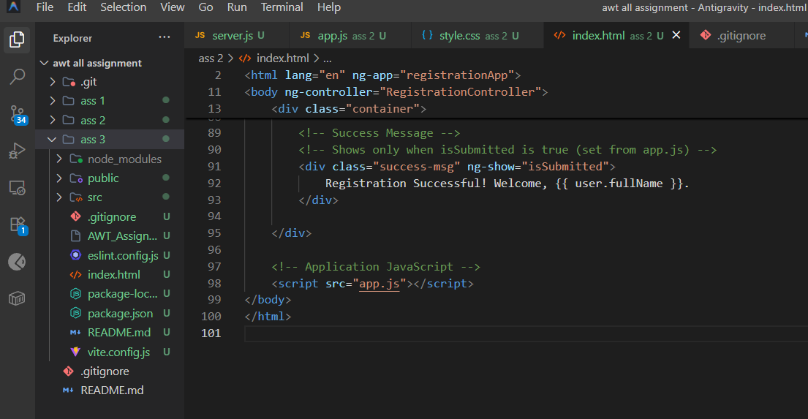
1. Home Page
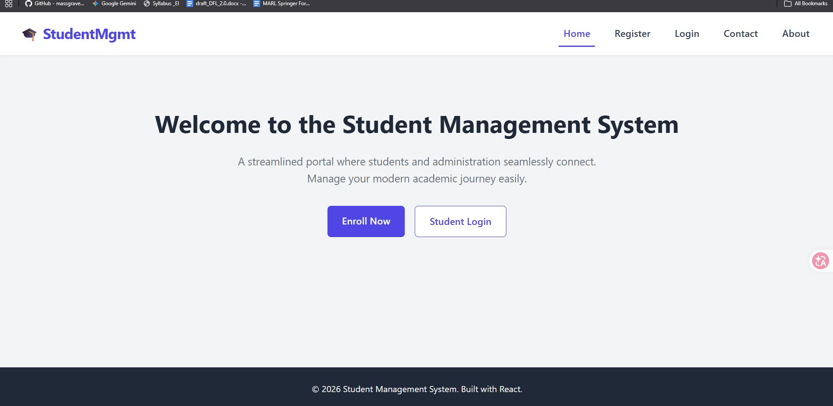
2. Student Registration Page
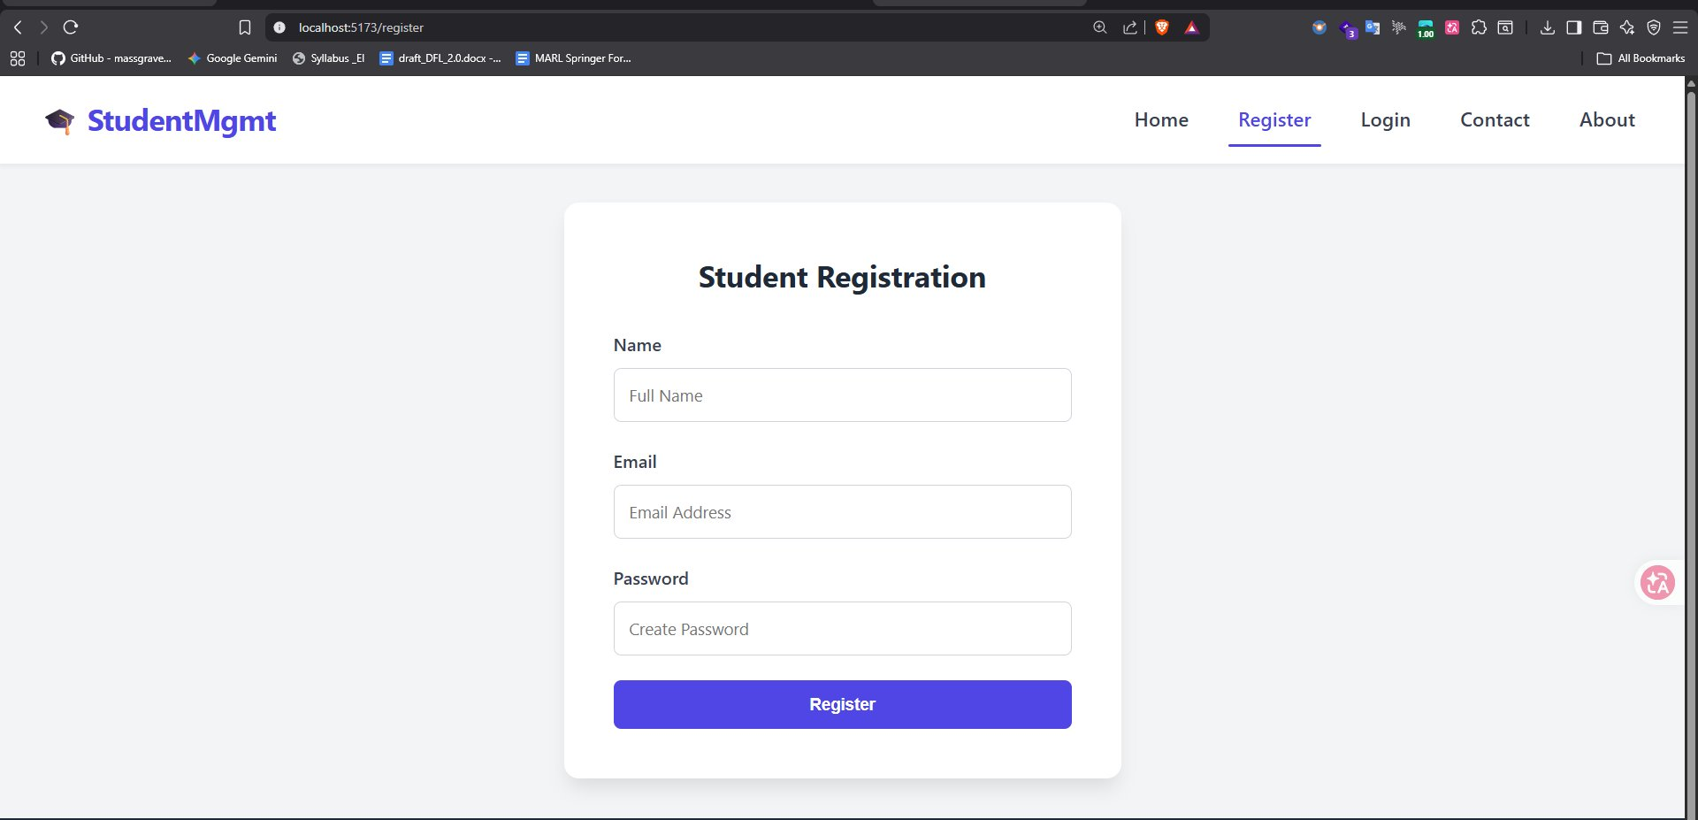
3. Student Login Page
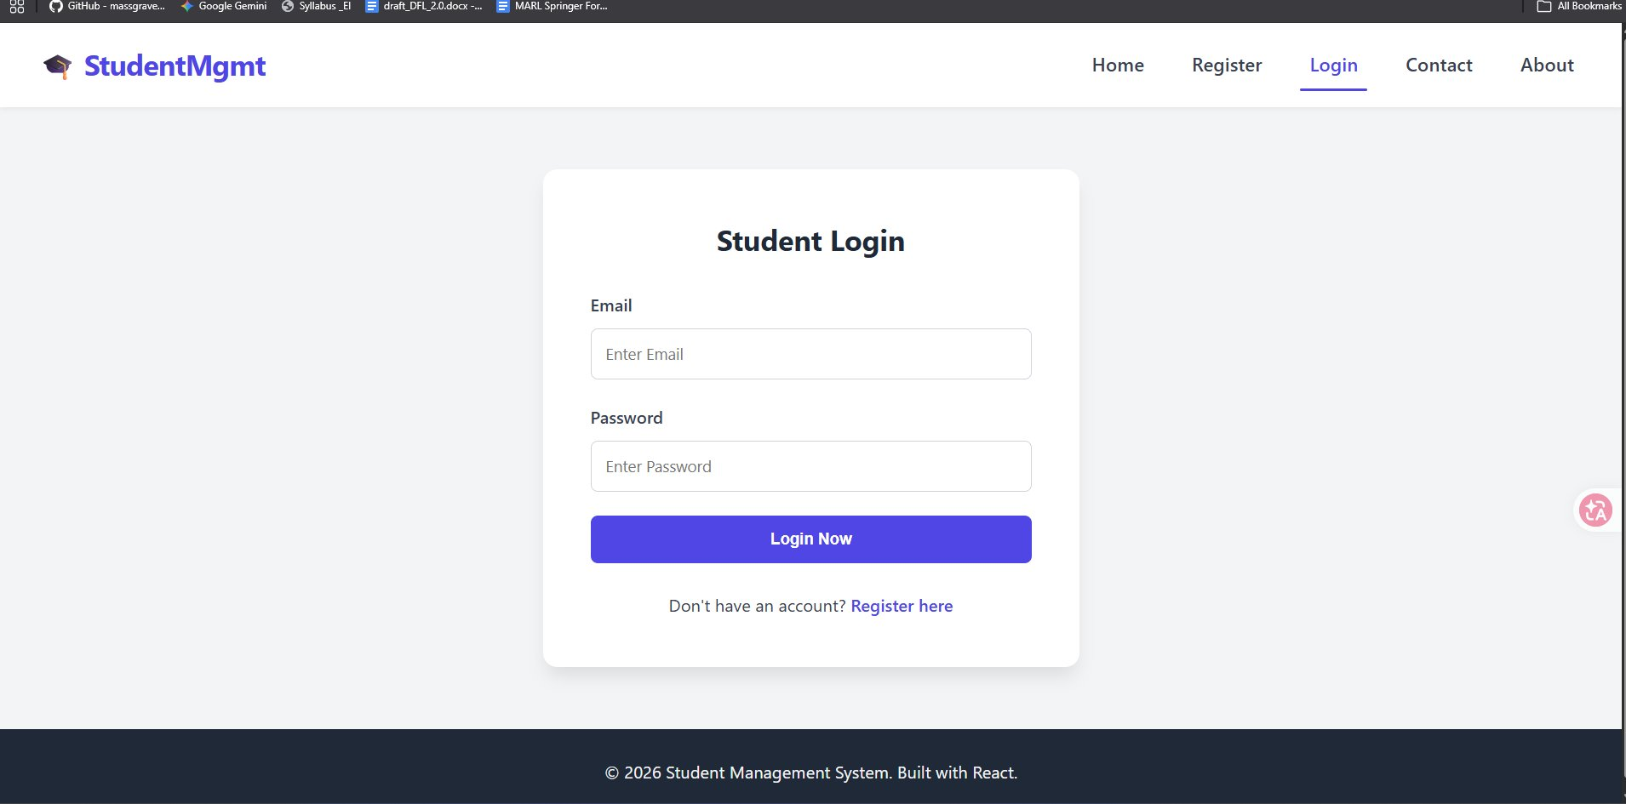
4. Contact Administration Page
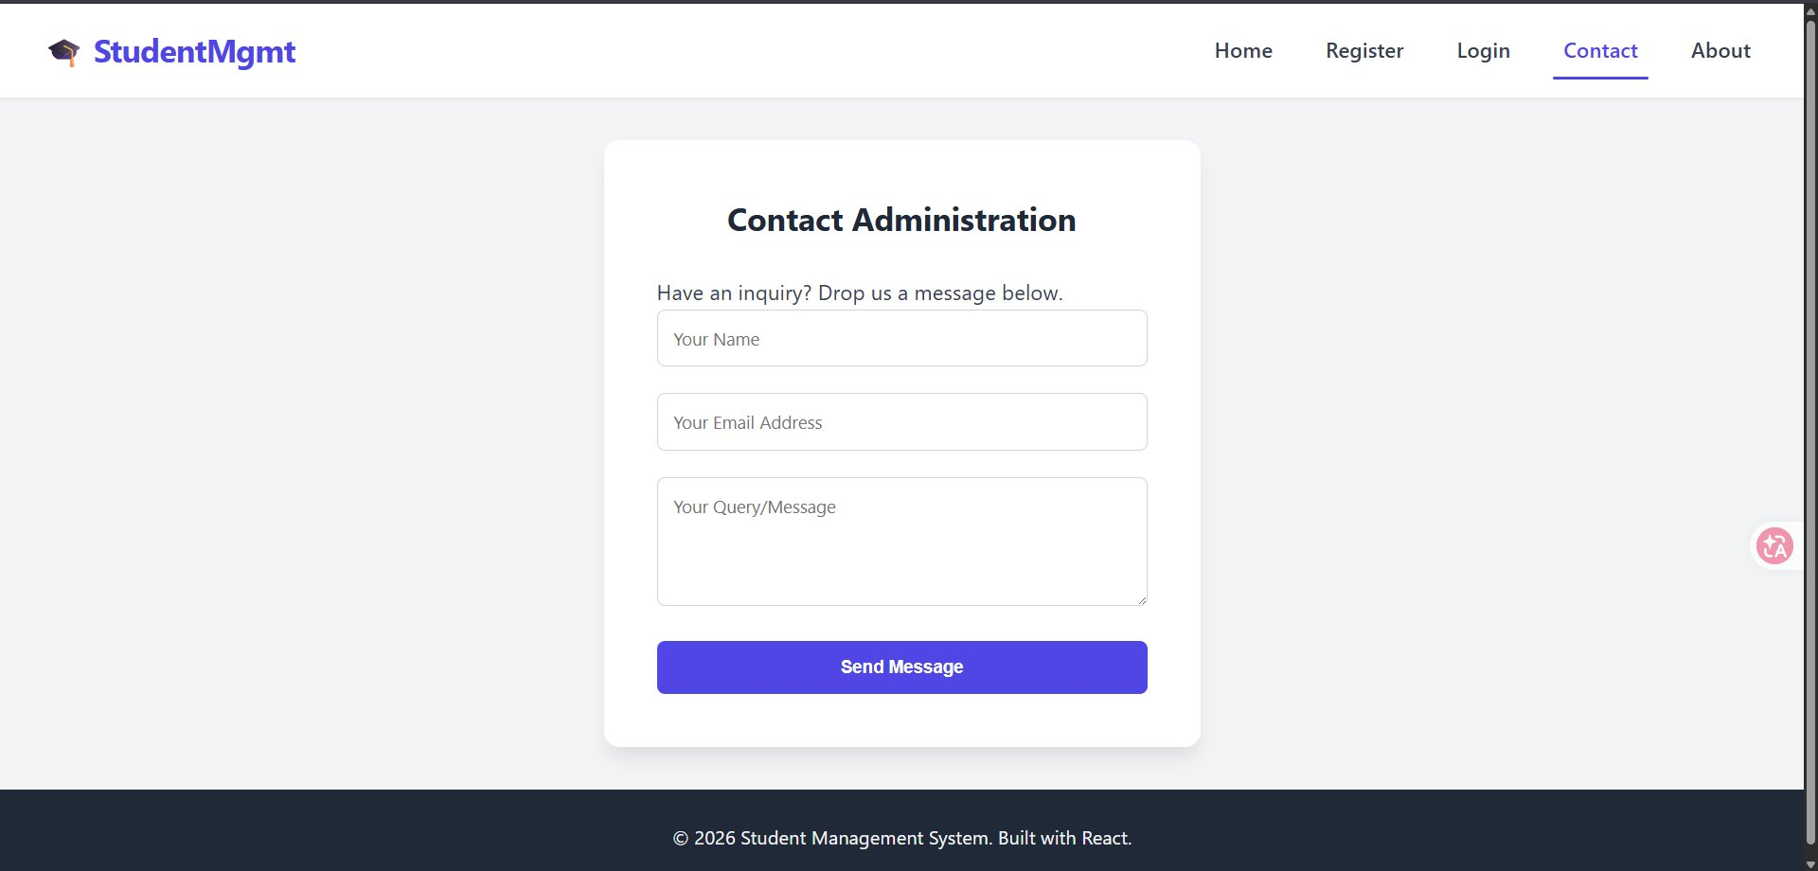
5. About the System Page
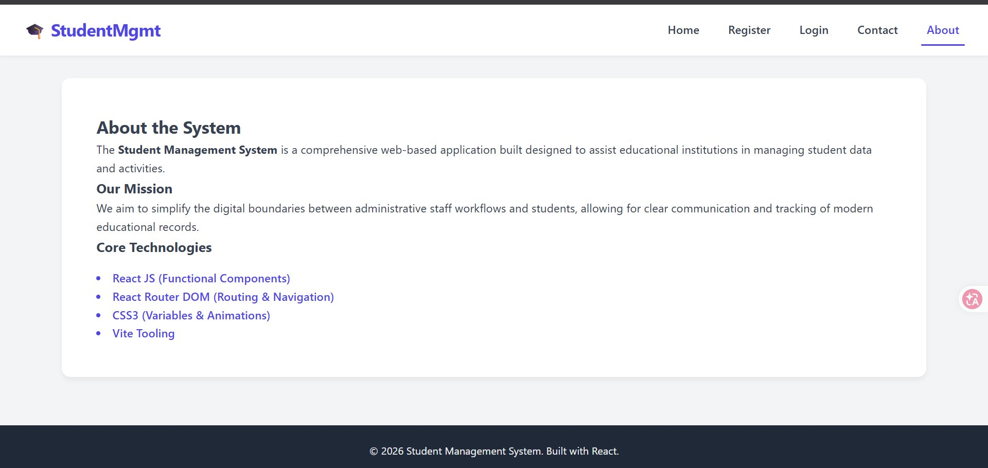

Conclusion:
In this assignment, a fully functional Student Management System was built using React JS with functional components. The application includes five distinct pages — Home, Register, Login, Contact, and About — with seamless client-side routing implemented via React Router DOM. The persistent navigation bar highlights the active route, and the project was scaffolded using Vite tooling with CSS3 for styling and animations.

